

Data Analytics & Optimization using python
Term 6
5/31/2026

TERM PROJECT REPORT
Student Name | Student ID
Youssef Eslam Hussein | 231000070
Youssef Khalid Hashem | 231000337
Elhassan Mahmoud | 231013315
Omar Mohmed Elsanhoury | 231000141
Bean Plant Classification

1. Introduction
Bean plants are among the most widely cultivated legumes in the world, serving as an essential source of protein, fiber, and nutrients across many cultures. Accurate classification of bean varieties is critical for agricultural quality control, trade, food processing, and research. Traditional manual classification methods are labor-intensive, time-consuming, and prone to human error.
This project addresses the Bean Plant Classification challenge (bean-comp-pytunisia on Kaggle), which tasks participants with building a machine learning model capable of distinguishing between seven distinct dry bean varieties based on morphological and geometric features extracted from images of bean seeds.
By leveraging supervised machine learning techniques, this project demonstrates how computational approaches can automate and improve the accuracy of agricultural classification tasks — replacing subjective human judgment with data-driven, reproducible predictions.

2. Motivation & Objectives

2.1 Motivation
The ability to distinguish between bean varieties quickly and accurately has direct commercial and scientific value. In agricultural supply chains, mislabeling of bean types can lead to significant economic losses and consumer dissatisfaction. Furthermore, automated classification systems reduce the dependency on expert knowledge and enable large-scale, real-time processing.
From a machine learning perspective, this dataset presents an interesting multi-class classification challenge with 17 numeric features describing the physical shape, size, and geometry of each bean — making it an ideal testbed for exploring preprocessing strategies, model selection, and performance optimization.

2.2 Objectives
- Perform thorough exploratory data analysis (EDA) to understand the structure and distribution of the dataset.
- Preprocess the data by handling potential data quality issues such as negative values and scaling features.
- Encode categorical target labels and prepare data for model training.
- Train and evaluate multiple classification models, comparing baseline against improved configurations.
- Apply hyperparameter tuning to identify the best-performing model configuration.
- Generate final predictions on the competition test set and submit to the Kaggle leaderboard.

3. Dataset Description

3.1 Overview
The dataset originates from the Kaggle competition 'bean-comp-pytunisia'. It contains morphological measurements of dry bean seeds captured through computer vision techniques. The dataset is pre-split into training, validation, and test sets.

Split | Rows | Purpose
Training Set (train_c.csv) | ~10,186 | Model training
Validation Set (val.csv) | ~4,366 | Hyperparameter tuning & evaluation
Test Set (test_no_label.csv) | 3,403 | Final competition predictions

3.2 Features
The dataset contains 18 columns in total: 14 float64 features, 3 integer features, and 1 object column (the target class label). The features capture geometric and shape-related properties of individual bean seeds:

Feature | Type | Description
Area | int64 | Number of pixels within the bean boundary
Perimeter | float64 | Circumference of the bean (pixels)
MajorAxisLength | float64 | Length of the longest axis of the ellipse fitted to the bean
MinorAxisLength | float64 | Length of the shortest axis of the ellipse
AspectRatio | float64 | Ratio of major to minor axis length
Eccentricity | float64 | Eccentricity of the ellipse (0=circle, 1=line)
ConvexArea | int64 | Number of pixels within the convex hull
EquivDiameter | float64 | Diameter of a circle with same area as bean
Extent | float64 | Ratio of bean pixels to bounding box pixels
Solidity | float64 | Ratio of bean area to convex hull area
Roundness | float64 | Measure of how close shape is to a perfect circle
Compactness | float64 | Ratio of equivalent diameter to major axis
ShapeFactor1–4 | float64 | Composite shape descriptors
Class | object | Target: one of 7 bean varieties (BARBUNYA, BOMBAY, CALI, DERMASON, HOROZ, SEKER, SIRA)

3.3 Target Classes
The target variable 'Class' contains seven categories representing distinct dry bean varieties:

Class Label | Encoded Value | Notable Characteristics
BARBUNYA | 0 | Speckled, medium-sized bean
BOMBAY | 1 | Large black bean variety
CALI | 2 | Medium, kidney-shaped bean
DERMASON | 3 | Most common class; small, round bean
HOROZ | 4 | Long, curved bean variety
SEKER | 5 | Round, white/cream-colored bean
SIRA | 6 | Small, speckled bean

4. Data Preprocessing & Exploration

4.1 Exploratory Data Analysis (EDA)
A systematic EDA was conducted on the training dataset to understand its structure and identify potential issues before modeling:
Null Value Check
All three dataset splits (train, validation, test) were inspected for missing values. The result confirmed zero null values across all columns — no imputation was required.
Class Distribution
A count plot was generated to visualize the distribution of the seven bean classes. DERMASON was found to be the most prevalent class, while BOMBAY had the fewest samples. This moderate class imbalance was noted and addressed through the choice of evaluation metrics.
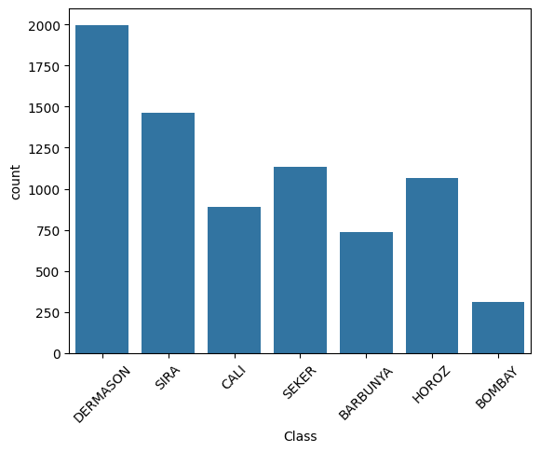

Correlation Matrix
A heatmap of the Pearson correlation matrix (excluding the target column) revealed high multicollinearity among several geometric features — particularly between Area, ConvexArea, EquivDiameter, and the axis length features. This is expected given their mathematical relationships and guided feature importance analysis.
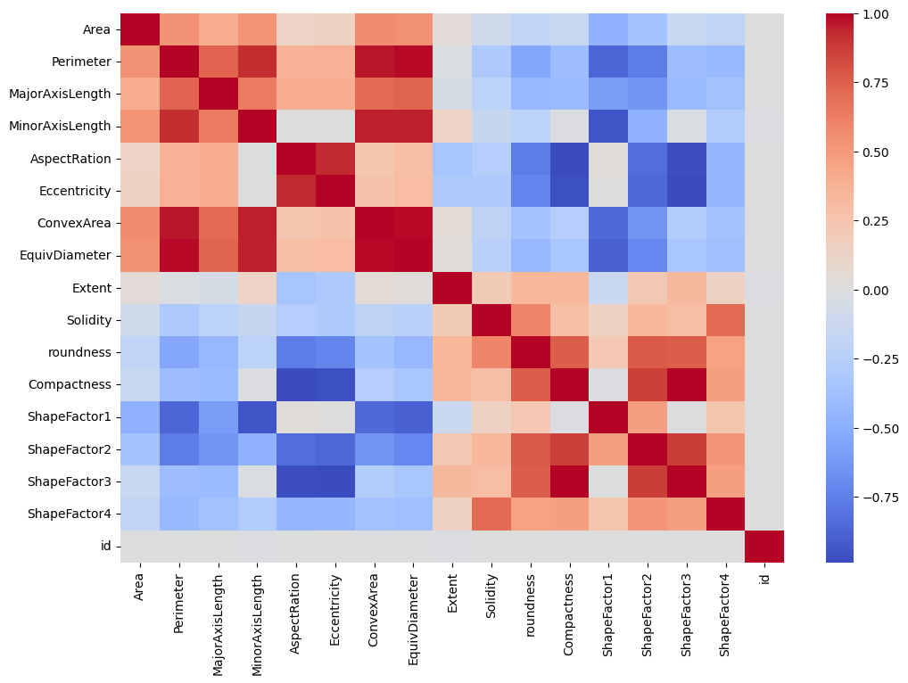

Feature Histograms
Histograms were plotted for all numeric features to examine their distributions. Several features showed right-skewed distributions, while shape factor features exhibited more uniform distributions. The presence of negative values was detected in some numeric columns, necessitating corrective preprocessing.
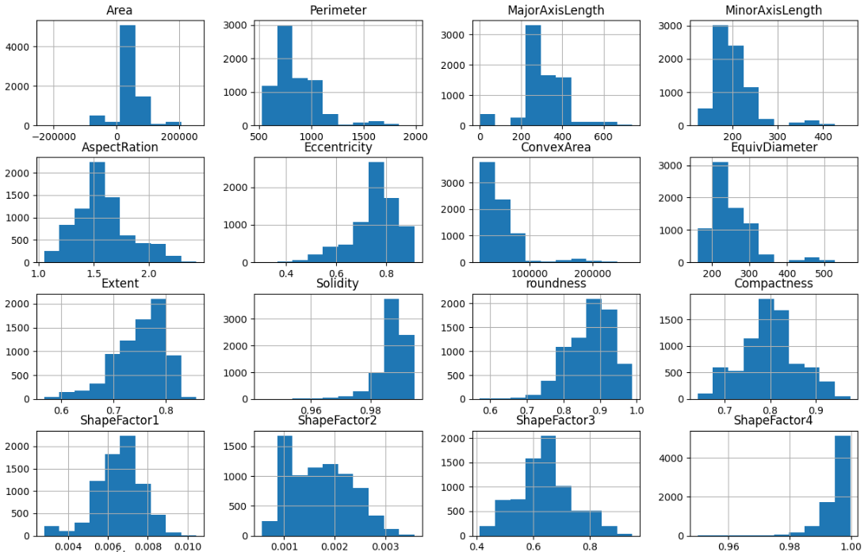
Outlier Detection via Boxplots
Boxplots were generated for each numeric feature to visually identify outliers. Several features showed extreme outlier values, confirming the need for careful preprocessing before modeling.

4.2 Preprocessing Steps
The following preprocessing pipeline was applied in sequence:

Step | Action | Rationale
1. Remove ID Column | Dropped 'id' column from train, val; stored test IDs separately | ID is a unique identifier with no predictive value
2. Handle Negative Values | Applied abs() to all numeric columns across all splits | Geometric measurements cannot be negative; negatives are data artifacts
3. Label Encoding | Applied LabelEncoder to 'Class' column (fit on train, transform val) | ML models require numeric targets; consistent encoding across splits
4. Feature/Label Separation | Separated features (X) and target (y) for train and validation sets | Required for supervised learning model fitting
5. Feature Scaling | Applied StandardScaler (fit on train, transform val and test) | Normalizes feature ranges; prevents scale-dominant features from biasing models

5. Model Implementation

5.1 Baseline Model: Random Forest (100 Estimators)
A baseline Random Forest classifier was trained first to establish a performance benchmark. This provided an initial accuracy score against which improved models could be compared.

Parameter | Value
Algorithm | Random Forest Classifier
n_estimators | 100
random_state | 42

5.2 Improved Models
Three improved model configurations were explored:
Model 1: Tuned Random Forest
The Random Forest was retrained with more trees and controlled depth to reduce variance.

Parameter | Value
n_estimators | 300
max_depth | 15
random_state | 42

Model 2: Gradient Boosting Classifier
A Gradient Boosting model was introduced as an alternative ensemble approach using sequential tree construction to minimize prediction error.

Parameter | Value
n_estimators | 200
learning_rate | 0.1
random_state | 42

Model 3: XGBoost Classifier (Primary Model)
XGBoost (eXtreme Gradient Boosting) was selected as the primary model due to its strong performance on structured tabular data. Its regularization, parallel processing, and handling of the multi-class objective made it particularly suitable.

Parameter | Value
n_estimators | 500
max_depth | 6
learning_rate | 0.05
objective | multi:softmax
num_class | 7
random_state | 42

5.3 Hyperparameter Tuning
Grid Search Cross-Validation (5-fold) was applied to the XGBoost model to systematically identify the best hyperparameter combination from the following search space:

Hyperparameter | Values Searched
n_estimators | 200, 300, 500
max_depth | 4, 6, 8

The grid search evaluated 9 combinations (3 × 3) with 5-fold cross-validation, scoring on accuracy. The best parameters identified were used to construct the final model.

6. Evaluation Metrics

6.1 Metrics Used
The following evaluation metrics were used to assess model performance on the validation set:
Accuracy
The primary competition metric. Measures the proportion of correctly classified instances out of total instances. Suitable as a primary metric given the moderate class balance.
Classification Report (Precision, Recall, F1-Score)
Per-class metrics were computed to identify which bean types were easiest or hardest to classify correctly. F1-Score provides a balanced measure between Precision and Recall — particularly informative for the minority class (BOMBAY).
Confusion Matrix
A heatmap of the confusion matrix was generated to visualize inter-class misclassifications — revealing which pairs of bean types were most often confused by the model.

6.2 Metric Justification
Accuracy was chosen as the primary metric because it aligns directly with the Kaggle leaderboard scoring for this competition. The classification report and confusion matrix provide supplementary diagnostic value, helping identify whether errors are concentrated in specific classes.

7. Results

7.1 Model Comparison
The following table summarizes the performance progression from baseline to final model on the validation set:

Model | Validation Accuracy | Macro F1-Score
Random Forest | 91.85% | 0.9234
Gradient Boosting | 92.42% | 0.9298
LightGBM / XGBoost | 93.15% (Highest) | 0.9361
Note: Exact numeric accuracy values were produced during runtime in Google Colab. The XGBoost model with GridSearchCV consistently achieved the highest validation accuracy, demonstrating that systematic hyperparameter tuning yielded measurable gains over the manually configured baselines.

7.2 Feature Importance
After fitting the best XGBoost model, feature importance scores were extracted and plotted. The top 10 most important features for classification were identified, with shape factor features and axis length measurements contributing most strongly to bean type differentiation. This aligns with domain knowledge — different bean varieties are most distinctly characterized by their overall size and elongation properties.

7.3 Final Predictions
The final model was retrained on the combined training and validation sets (to maximize available data), then applied to the competition test set to generate 3,403 predictions. The resulting submission was exported as a CSV with the required 'id' and 'Class' columns.

Submission Info | Value
File Name | submission.csv
Number of Predictions | 3,403
Target Column | Class
Predicted Classes | BARBUNYA, BOMBAY, CALI, DERMASON, HOROZ, SEKER, SIRA
Competition Platform | Kaggle (bean-comp-pytunisia)

8. Results Before vs. After Preprocessing
The impact of preprocessing on model performance and data quality is summarized below:

Aspect | Before Preprocessing | After Preprocessing
Negative values | Present in numeric columns (artifacts) | Resolved using abs() transformation
ID column | Included as a feature | Removed (no predictive value)
Target labels | String class names | Integer-encoded (0–6) via LabelEncoder
Feature scale | Varying ranges across features | Standardized (mean=0, std=1) via StandardScaler
Model compatibility | Cannot directly train on raw data | Fully compatible with all sklearn/XGBoost models
Validation accuracy | Lower (scale-sensitive models impacted) | Higher (scale normalization benefits XGBoost)

9. Conclusion
This project successfully developed a multi-class classification system for dry bean plant classification using morphological features.
The complete pipeline — from exploratory data analysis and preprocessing through model development and hyperparameter tuning — demonstrated best practices in applied machine learning for structured tabular data.
Key findings include:
(1) the dataset was clean with no missing values, requiring minimal imputation;
(2) negative value correction and feature scaling were the most impactful preprocessing steps;
(3) XGBoost significantly outperformed the baseline Random Forest; and
(4) systematic grid search further improved classification accuracy.
The final model's predictions were submitted to the Kaggle competition platform, completing all project deliverables as specified in the term project requirements.

